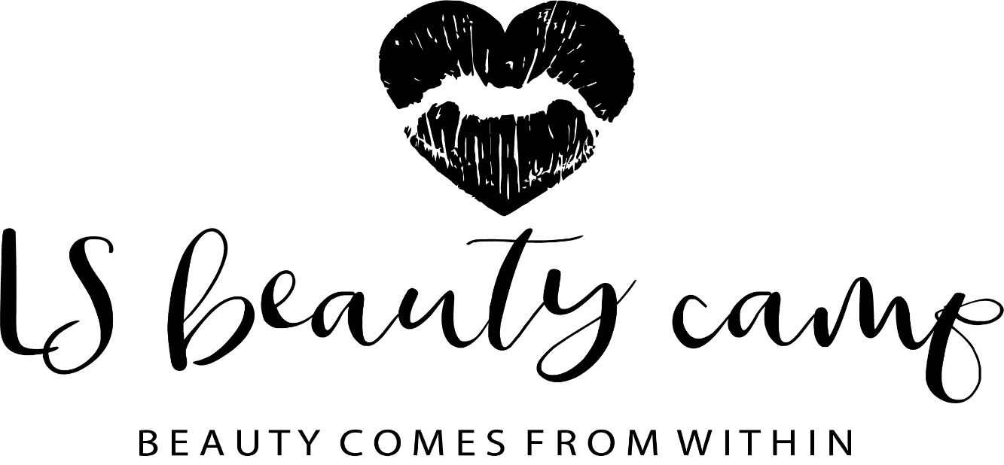

Permission to apply skin care and beauty products to the nails and skin. The products that we will be using are Cuccio naturale products, the body shop products and nail varnish { clear varnish or coloured varnish can be removed after the group for school}. These products are made with natural ingrediants and are suitable for sensitive skin types.
Childs name: ………………………………. Date of birth : ……………………………………
I give permission for staff at LS Beauty Camp to apply these products to my childs skin.
I would like the staff at LS beauty camp to apply a skin patch test prior to using any of these products as my child does have sensitive skin …………………………………

Parents signiture……………………….. Date ………………………………………………

