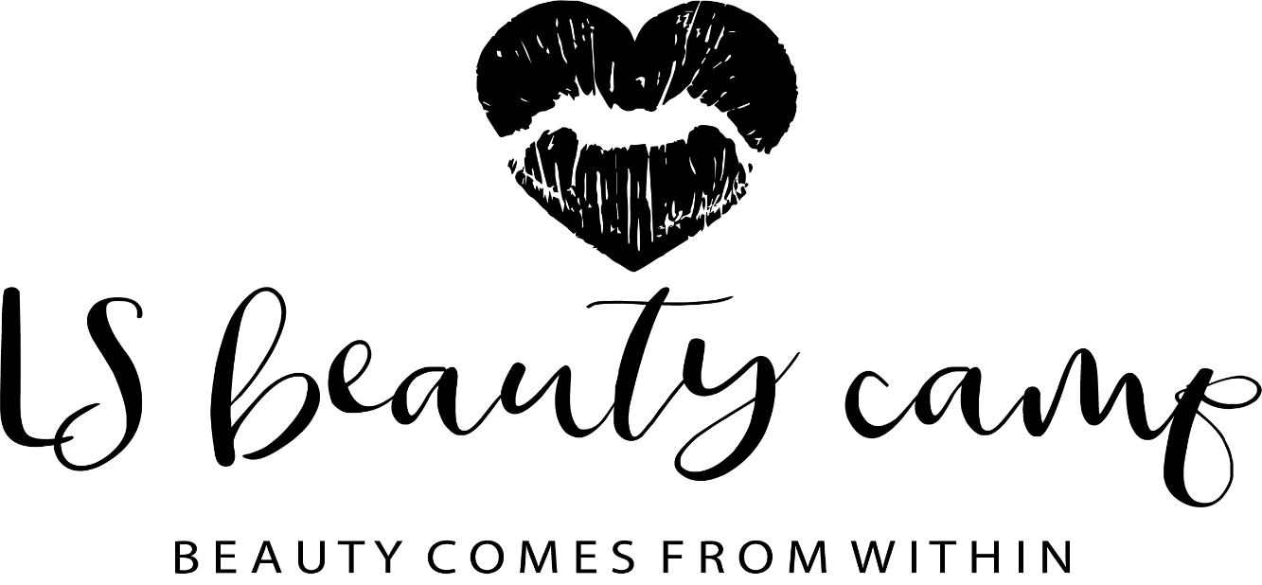

Photograph permission

For marketing purposes, there may be occassions that staff at LS beauty camp take photos of the children participating in the group. If this occurs, it will be a photo of the children participating in the activities, there will be no faces in the pictures.

Childs name: ……………………………………………………… Date of birth …………………………………………………

I give permission for staff at LS beauty camp to photograph my child interacting in the group for marketing purposes.

Parent signiture : ………………………………………… Date ……………………………………….

